**Group 17**Name : Atahar Hossain Piash  
ID : 2231877642

Name : Shawlin Salit  
ID : 2212906042

Course : CSE311  
Section : 1  
  
Topic : Hospital Management system

**ERD:**

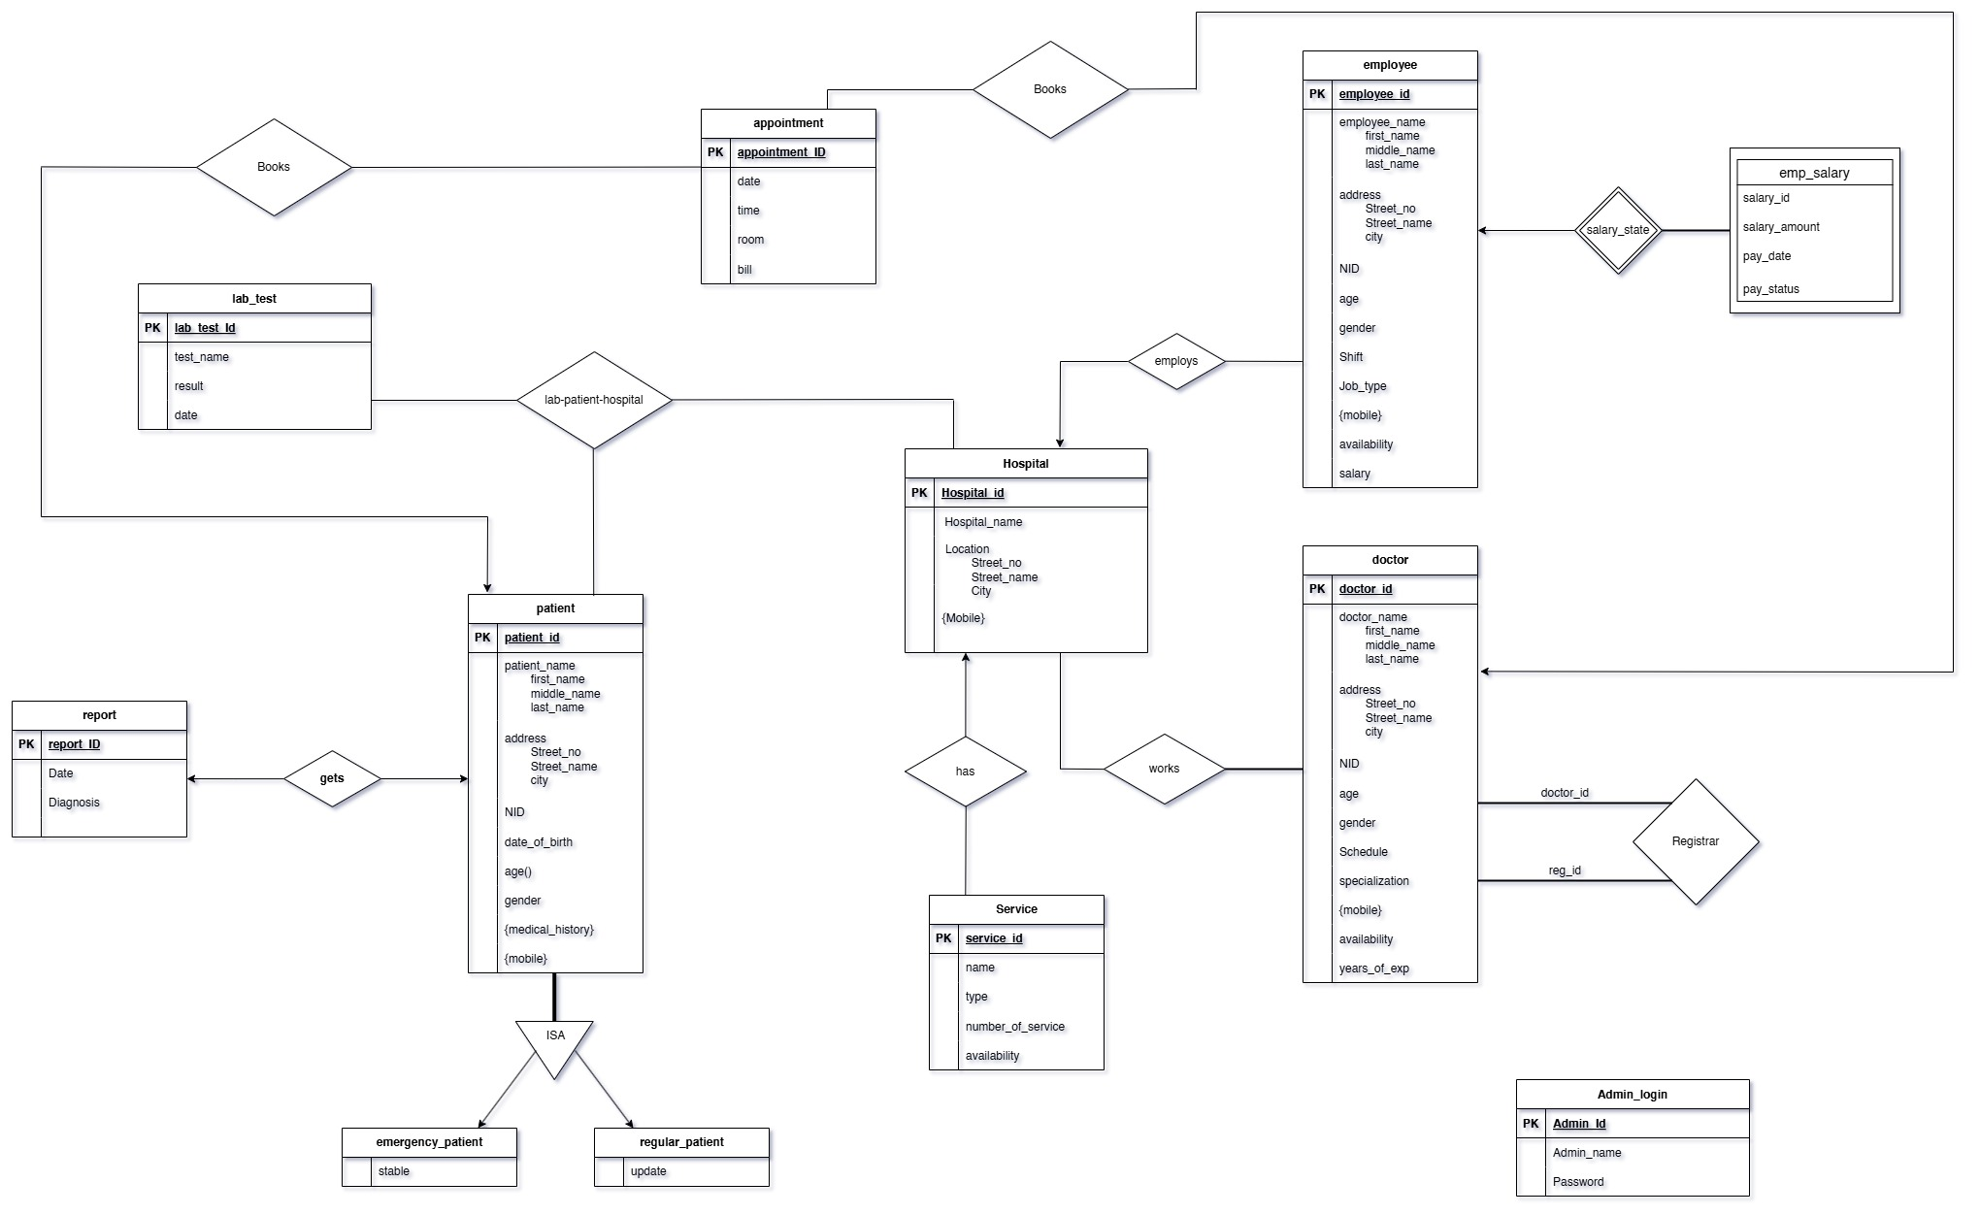

**Relation schema:**  
  
Admin_login (Admin-id, Admin_name, Password)

Hospital (Hospital-id, Hospital_name, Street _no, Street_name, City)

Hospital_Mobile (hospital-id, mobile)

Service (service- id, name, type, number_of_service, availability, **Hospital-id**)

Doctor (Doctor- id, first_name, middle_name, last_name, Street_no, Street_name, city, NID, age, gender, Schedule, specialization, availability, years_of_exp)

Doc_mobile(Doctor-id, mobile)

Registrar (Doctor-id, reg-id)

Works (Hospital-id, Doctor-id)

Employee (Employee -id, first_name, middle_name, last_name, Street_no, Street_ name, city, NID, age, gender, Shift, Job_type, availability, salary, **Hospital-id**)

emp_salary (Employee-id, salary-id, salary-amount, pay-date, pay-status)

Patient (Patient-id, first_name, middle_name, last_name, Street_no, Street_name, city, NID, Date_Of_Birth, gender)

Pat_Mobile (Patient-id,mobile)

Pat_Medical_History (Patient-id, Medical-History)

emergency_patient (patient-id, stable)

regular_patient (patient-id, update)

Report (report-id, Date, Diagnosis, **patient-id**)

lab_test (lab-test-id, test_name, result, date)

lab_patient_hospital (Hospital-id, Patient-id, lab-test-id)

Appointment (Appointment-Id, date, time, room, bill, **Patient-id**, **Doctor- id**)

Instructions:

1. Entities: strong entities (Hospital, Patient, Doctor, Employee, Service etc.),  
   weak entities(emp_salary)
2. Relationships:

One-to-one (patient and report),  
One-to-Many (Hospital and Employee, Hospital and Service) /Many-to-One (Doctor and Appointment),  
Many-to-Many (Doctor and hospital)

1. Specialization (emergency_patient, regular_patient)
2. Role(registrar)
3. Ternary Relationship (lab_patient_hospital)
4. Composite (address and name), multivalued (phone and medical history) and derived attributes(age)